
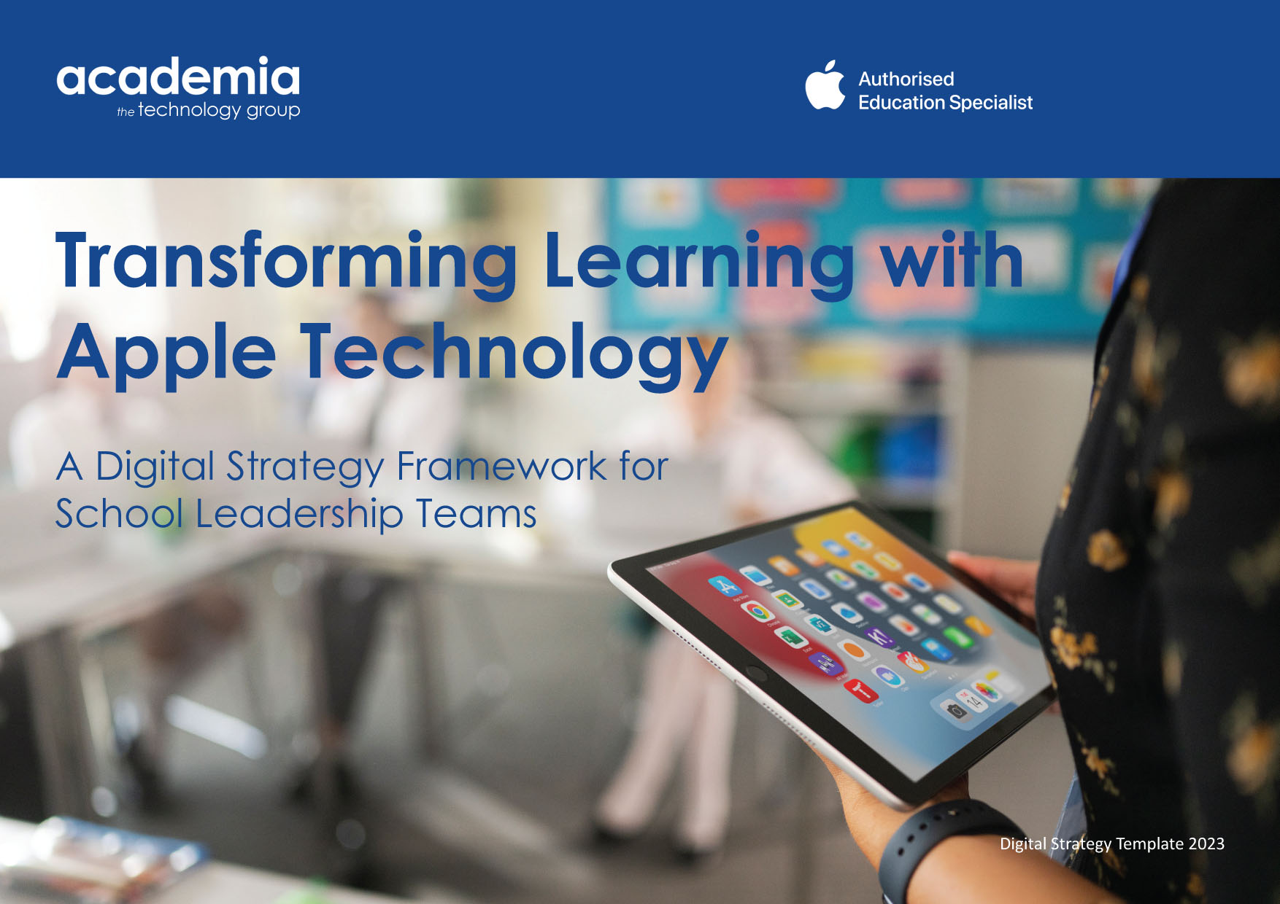

Table of Contents
Introduction 4
Purpose and Structure 4
What you need to do 5
Section 1: Planning and Preparation 7
Section 2: Vision 14
What to Do Next?. 19
Useful Resources 20



Introduction
Thank you for downloading our Digital Strategy Framework Document. It has been created by Academia and educators with extensive experience in supporting schools, trusts, colleges and universities nationally to maximise their investment in technology. Throughout this document, “school” has been used to refer to any educational establishment - nursery, school, college, institution or trust. Similarly, “pupil” is used to refer to pupils, students and learners, and “teacher” refers equally to teachers and supporting staff - TAs, LSAs, and HLTAs.

Purpose and Structure
By taking time to reflect on the provided information, respond to key questions and complete activities, your school will have an essential outline framework of a strategic document. You will be in a better “state of readiness” to clearly articulate how your commitment to investing in technology is directly linked to enhancing the quality of education in your school. This will enable you on your journey to make an informed decision about sustainable investment in technology-enhanced learning.

This document is highly practical and structured into five key sections, outlined below. Within each section, you will find Background Information, Key Questions for Consideration and a Practical Activity. These may not be in the same order due to the character of the section.

Planning and Preparation | Vision | Teaching | Learning | Environment
Developing systems and processes to achieve enhanced quality of education | Articulating vision and direction, and aligning learning with the potential of technology | Exploring ways in which technology transforms teaching in the classroom and beyond | Exploring ways in which technology transforms the quality of learning | Ensuring the physical environment and infrastructure are fit for purpose

What you need to do
This document is an interactive template for creating your school’s digital strategy. The sections where you are required to add information or conduct an activity are clearly flagged as per the key below.
Activity
Where you see the following shaded box and blue text inside square brackets, you will be required to enter information specific to your school and the journey you want to go on with your Digital Strategy.
[Write Your Answers Here]

Suggested External Support.
To assist you with completing some of the above sections, we have flagged where there is additional support available from Academia. This might be requesting a link to a free online survey your school can use to conduct a “Transforming Learning with Technology” audit with your staff or inviting an Academia expert or Apple Professional Learning Specialist into your school to run a practical workshop. Where external support is available, you will see the following blue box:
 | ACTION: | Details of what support is available and what you need to do in order to take advantage of it will be written here



Section 1: Planning and Preparation

Background Information: Steering Group
Many schools supported by Academia have found it valuable to create a leadership-level Digital Steering Group. This group should have strong representation from Leadership, Finance, Teaching and Learning, and onsite or offsite IT Services. The steering group is responsible for ensuring that technology is aligned with the school vision and the short, medium, and long-term priorities in the School Improvement Plan.
Academia can provide education-driven support to the steering group to ensure that all investment in technology is linked to the intended impact on the quality of education and the wider learning environment.

At the individual school level, this group usually has core representation from
- Head Teacher
- Deputy Head/Assistant Head Teacher with responsibility for curriculum delivery
- Finance Manager/Bursar
- IT Manager

At the trust level, this group would have core representation from
- CEO
- Head Teachers
- Deputy Head Teachers with responsibility for curriculum delivery and attainment
- Director of Finance
- Digital Learning Lead/Manager
- IT/Network Manager(s)

It can include an interested governor or board member, SENDCO and teacher(s) who may be responsible for leading on Digital Learning.

To encourage collaboration within or outside of meetings, you could upload this document into a shared online space. For example, if your school uses Microsoft365, you could create a Team with different channels for different sections. Key staff could contribute via chat at any time and add comments to the document. If your school uses Google Workspace for Education, you could set up a specific Google site or a Google Classroom. If your school does not yet have a collaborative space, you could sign up and create an online discussion board using Padlet.

Activity: Create a Digital Steering Group
Identify proposed members of your Digital Steering Group. Your school may wish to use a pilot approach, by first creating a small core team before developing a larger team. Bring your Steering Group together. Share its purpose and explain the focus on Vision, Teaching, Learning and Environment, using the key sections below for guidance.

Questions for Consideration (Complete all that apply)

How will you determine membership of the Steering Group? | [Write Your Answers Here]
Will members be selected or invited to join? | [Write Your Answers Here]
How often will the group need to meet? | [Write Your Answers Here]
When is the optimal time to meet for high quality engagement? | [Write Your Answers Here]
Will meetings be conducted face to face, online or hybrid? | [Write Your Answers Here]
Where will core documentation be stored for access and collaboration? | [Write Your Answers Here]
What could be standing items on the agenda? Can they be assigned to specific people in the steering group? | [Write Your Answers Here]
Who will take responsibility for each item? | [Write Your Answers Here]
By forming a Digital Steering Group we will be able to… | [Complete the statement here]

Steering Group
Name | Role | Responsibilities
[Write Name Here] | [Write Role Here] | [Write Key Responsibilities Here]
[Write Name Here] | [Write Role Here] | [Write Key Responsibilities Here]
[Write Name Here] | [Write Role Here] | [Write Key Responsibilities Here]
[Write Name Here] | [Write Role Here] | [Write Key Responsibilities Here]
[Write Name Here] | [Write Role Here] | [Write Key Responsibilities Here]
[Write Name Here] | [Write Role Here] | [Write Key Responsibilities Here]
[Write Name Here] | [Write Role Here] | [Write Key Responsibilities Here]  (Press TAB in this cell to create a new row)

Information: Plan for Change
As part of a change management process, your school needs to: define a clear vision; actively plan for change; articulate and communicate change; ensure it is ready for change; plan and develop processes to support staff with change; identify key milestones of progress; and have clear indicators to measure the success of change.

Organisational Change can be “Adaptive” or “Transformational”. Adaptive changes are small in scale and often gradual and iterative. Adaptive changes are intended to evolve and improve workflows, processes and strategies over time, and may involve a small number of people. Transformational changes are large in scale. They are often a significant change to existing practice and affect a large number of people.

“Change Management” is the process of guiding your school from the earliest of ideas and preparation through implementation to realisation or resolution. For this to happen successfully, an effective strategy is essential to provide clarity of the vision, interim processes, how success will be measured, managing planned and unplanned change. There are logistical elements that need to be anticipated and planned for - work which may happen during the school day or outside school hours.

Successful change is dependent on the culture in your school. Staff and pupils will need to “buy in” to the proposed change, for example in their role as class teacher, subject leader, phase leader, or head of department. John Kotter found that for change to be successful, 75% of leaders in an organisation need to “buy in” to proposed change.

Change by its nature is disruptive. Every school will find its own way of defining and creating success.

Activity: Change Management in Your School Context

With your steering group, reflect on recent changes that have happened in school. They do not need to be related to technology. Identify the type of change. Reflect on the success of each change. Record what lessons were learnt.

It may be that the change was well intended but would have been better implemented at a different time of year. Perhaps a change could have been better planned and communicated to avoid people feeling “done to” and not owning the process of change. Maybe more time spent curating information would have avoided change having to be paused.

Is there a pattern to lessons you have learnt? Could the changes be process-based, role-based or time-based? Note the top lessons learnt that you can actively take into consideration when you plan for subsequent change- and how technology has the potential to enhance the process.

Adaptive (small-scale) Change | Key Lessons Learnt
[Example: changing printers in school due to obsolescence] | [Write what lessons you learned]
[Example: moving staff morning briefings online due to Covid] | [Write what lessons you learned]
[Example: removing digital cameras from each classroom] | [Write what lessons you learned]  (Press TAB to create a new row)

Transformational (large-scale) Change | Key Lessons Learnt
[Example: expanding to three form entry with associated building works] | [Write what lessons you learned]
[Example: staggering the start and end of school day] | [Write what lessons you learned]
[Example: moving school MIS] | [Write what lessons you learned]  (Press TAB in this cell to create a new row)

Questions for Consideration
(Complete all that apply)

What scale of change is anticipated? | [Write Your Answers Here]
Why are you making this change? | [Write Your Answers Here]
What is the timescale for change? | [Write Your Answers Here]
How will you engage all stakeholders? | [Write Your Answers Here]
At what key milestones, what will you need to communicate and how will you do it? | [Write Your Answers Here]
Who will be responsible for signing off on planned progress? | [Write Your Answers Here]
What will the process be to manage unplanned changes? | [Write Your Answers Here]
What expert/external sources of advice will enable you to make an informed decision? | [Write Your Answers Here]
Any other notes | [Write Your Answers Here]  (Press TAB in this cell to create a new row)


Section 2: Vision

A clear, high-level vision will enable you to maximise existing and proposed investment in digital learning and increase efficiency in its widest sense. Many examples of success can be attributed to organisations that set out to focus on and answer “why” not “what” – a leadership point made by Simon Sinek in his book, “Start with Why”.
Systematic analysis will provide a clear picture of where you now are, and how your vision will be defined from this point. Take time to build a clear picture with a robust evidence base of where you are now; what you are already doing well; and why it has been successful. It is important that you have captured a snapshot of where you currently are now and measure your journey from this point. Due to the nature of change, there will be moments when your school may feel you are not making progress – or making progress at the same rate. Take time to find out what other schools are doing well; why they are doing it; what the impact has been; and how it might translate to your own context. For example, talk to nearby schools or schools on the same wavelength as you. You may wish to visit an Apple Distinguished School to see how technology can enhance learning and teaching - from vision to reality.

Activity 1: Initial Discussion and Engagement
In your steering group (or maybe later with wider staff), select questions below that resonate directly with you. This could also be in a staff meeting; department groups, or individual release time.

If your school has a motto, what is the link between the motto and your intended use of technology? | [Write Your Answers Here]
How does your intended use of technology align to your school values? | [Write Your Answers Here]
How could your use of technology raise attainment and contribute to broader, deeper learning? | [Write Your Answers Here]
To what extent does your investment in technology to date represent value for money in your school? | [Write Your Answers Here]
In which ways can success of your existing investment in technology be measured? | [Write Your Answers Here]
Technology will enhance our school vision by… | [Write Your Answers Here]

[Here is some space for additional notes]
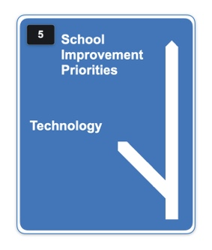
Activity 2: School Improvement Plan
In your Steering Group, with SLT or with staff, review your current School Improvement Plan. In what direction is technology taking your school? Is it a priority in its own right, or is it a means by which other priorities can be achieved?

For example, if developing language and communication in EYFS is a priority, how can technology enable this to be achieved? If developing an understanding of key mathematical or scientific concepts is a priority, how can technology enable deeper learning and a sense of mastery?

Questions for Consideration

How is technology referenced in your school improvement plan? | [Write Your Answers Here]
Does it have a separate section or is it integrated as a mechanism for success in other sections? | [Write Your Answers Here]
What does this say about your school’s perception of, and belief in, the potential of technology? | [Write Your Answers Here]
Review successes in your school in the last year which were identified in the previous activity. How did existing technology contribute to each success? | [Write Your Answers Here]

How robust is your evidence base? | [Write Your Answers Here]
Technology will support our current school improvement priorities by… | [Write Your Answers Here]

There are different workshops available to support your Steering Group with defining and refining the vision for learning and teaching with technology. Academia works closely with Apple Professional Learning Specialists – current and former teachers – who can readily assist your school.

What to Do Next?

Please contact Barnaby and Kristian, who will guide you through the following stages:

2: Vision Workshop follow up
3: Teaching with technology
4: Learning with technology
5: Environment
6: Next steps
- Communication
- Deployment



Kristian Taylor
Schools Development Manager
Barnaby Morton-Woodruff
Sales Manager, Schools

info@academia.co.uk
01992 703900

Useful Resources
Useful Resources

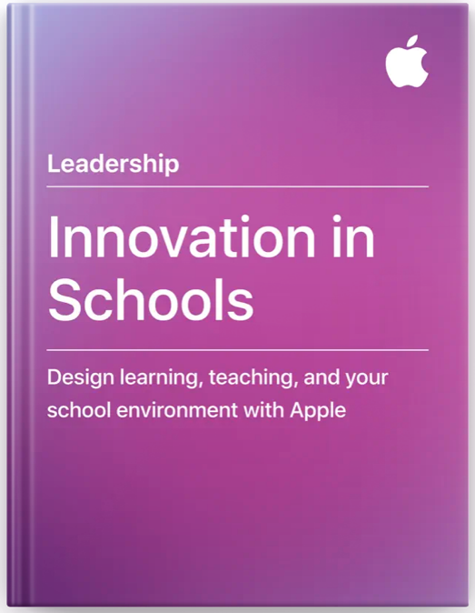 |  | 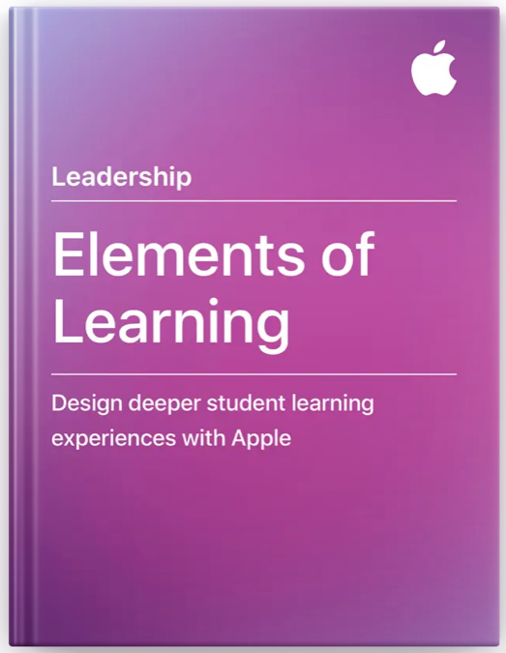
Innovation in Schools shows how innovative leaders leverage technology to develop learning, teaching, and their school environment.  It outlines the stages of innovation we see schools go through when they introduce, integrate, then innovate with new technology. | The most innovative schools around the world share common elements that leadership develops, and the community lives by.  The education team at Apple has built relationships with educators from these schools over the last 40 years to understand what makes them work well and how they embrace technology to create learning environments that are connected, collaborative, creative, and personal. | Elements of Learning provides research-based strategies for designing student learning experiences with iPad and Mac.  The book covers five elements of deeper learning, supported by a rubric, interactive examples, and 19 downloadable lessons, designed by teachers around the world. Teachers and technology specialists can use this book to design innovative and effective learning experiences with Apple technology.
https://books.apple.com/gb/book/innovation-in-schools/id1321127528 | https://books.apple.com/gb/book/elements-of-leadership/id1267616976 | https://books.apple.com/gb/book/elements-of-learning/id1367981260
Apple Education
Apple Education Community is a professional learning hub designed for educators who use Apple technology, including access to the Apple Teacher Programme. Find helpful resources for any skill level - from quick tutorials to inspirational ideas. Grow in this collaborative space as you connect with peers and experts for advice, shared stories, and more.

Apple Books
There are many books on the Apple Book Store written by Apple and by Apple Distinguished Educators worldwide. Some are intended for a Leadership audience, including the books illustrated above; others are designed to illustrate and harness the potential of technology and creativity across the curriculum. There are useful resources for a technical audience including IT and Deployment Guides.

Apple Regional Training Centres
Share Best Practice – Build Community – Inspire Excellence.
Apple Regional Training Centres are a community of educators and institutions, that provide online and face-to-face training, to build the skills and confidence of educators in using Apple technology inside and outside the classroom. We provide training and support to educators across the UK and Ireland, to explore the potential of Apple technology to enhance teaching and learning.

Apple Distinguished Schools
Apple Distinguished Schools are centres of leadership and educational excellence that demonstrate Apple’s vision for learning with technology — and we believe they are some of the most innovative schools in the world.

Apple Professional Learning Specialists
Apple Professional Learning Specialists are educators uniquely qualified to demonstrate how best to use Apple products for learning and teaching. They coach, mentor and support teachers in advancing their technology skills, with an emphasis on innovation — to engage students in deeper learning. Coaching sessions are available in-person and virtually.

iPad and Mac in Education Results | June 2022
This document shares the successes that K-12 and higher education institutions have observed with Apple devices, both in and out of the classroom.



